Download your Certificate
  - Title IX Training
- Log on to Bridge LMS
  - You’ll need your NUID and Password
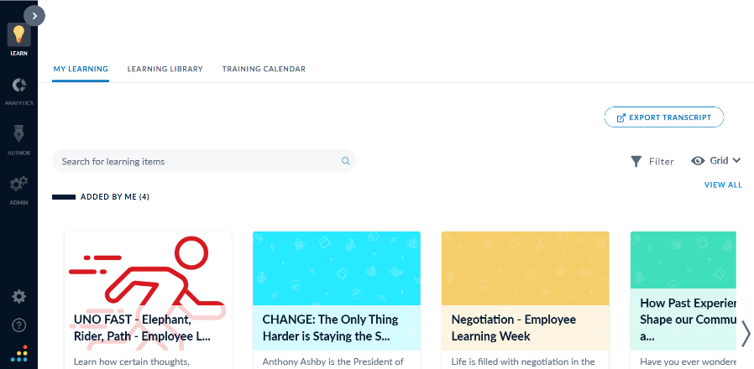

Figure 1Screen When logged into Bridge LMS

- Scroll down to the “Completed” Section
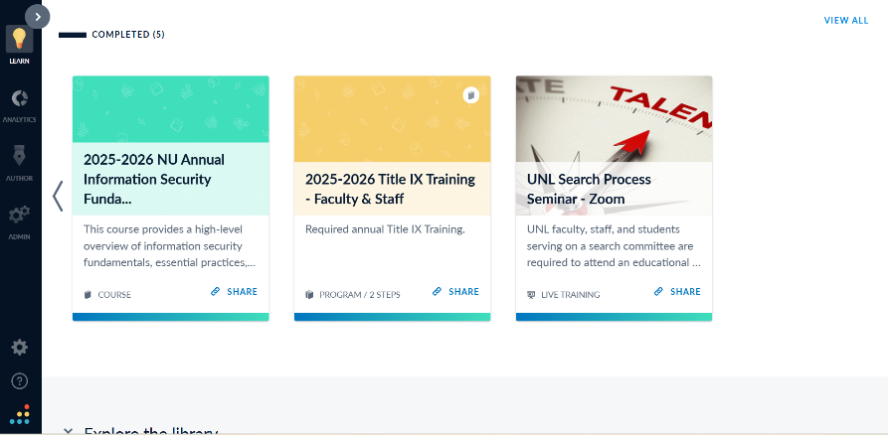

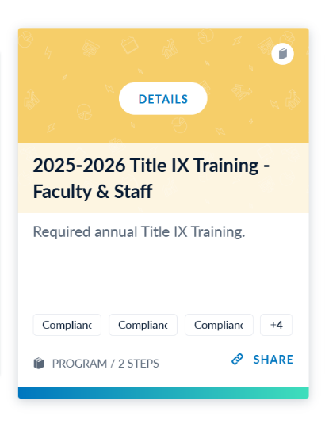
- Hover over the Title IX training tile to make the “Details” button appear
- Click on the “Details” button.

- A side panel will open.
- Click on “View Certificate.”
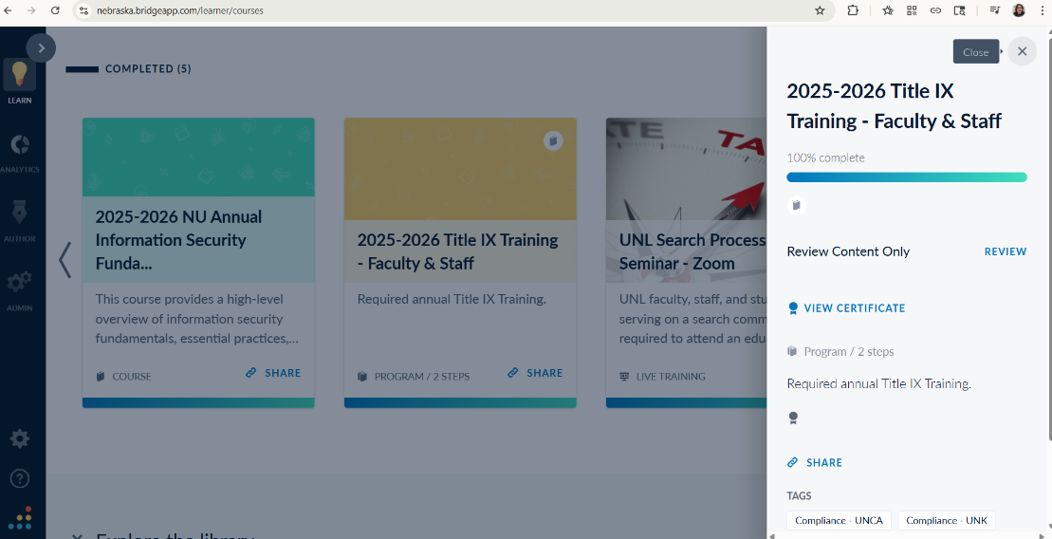

- In the next screen, you will see your certificate.
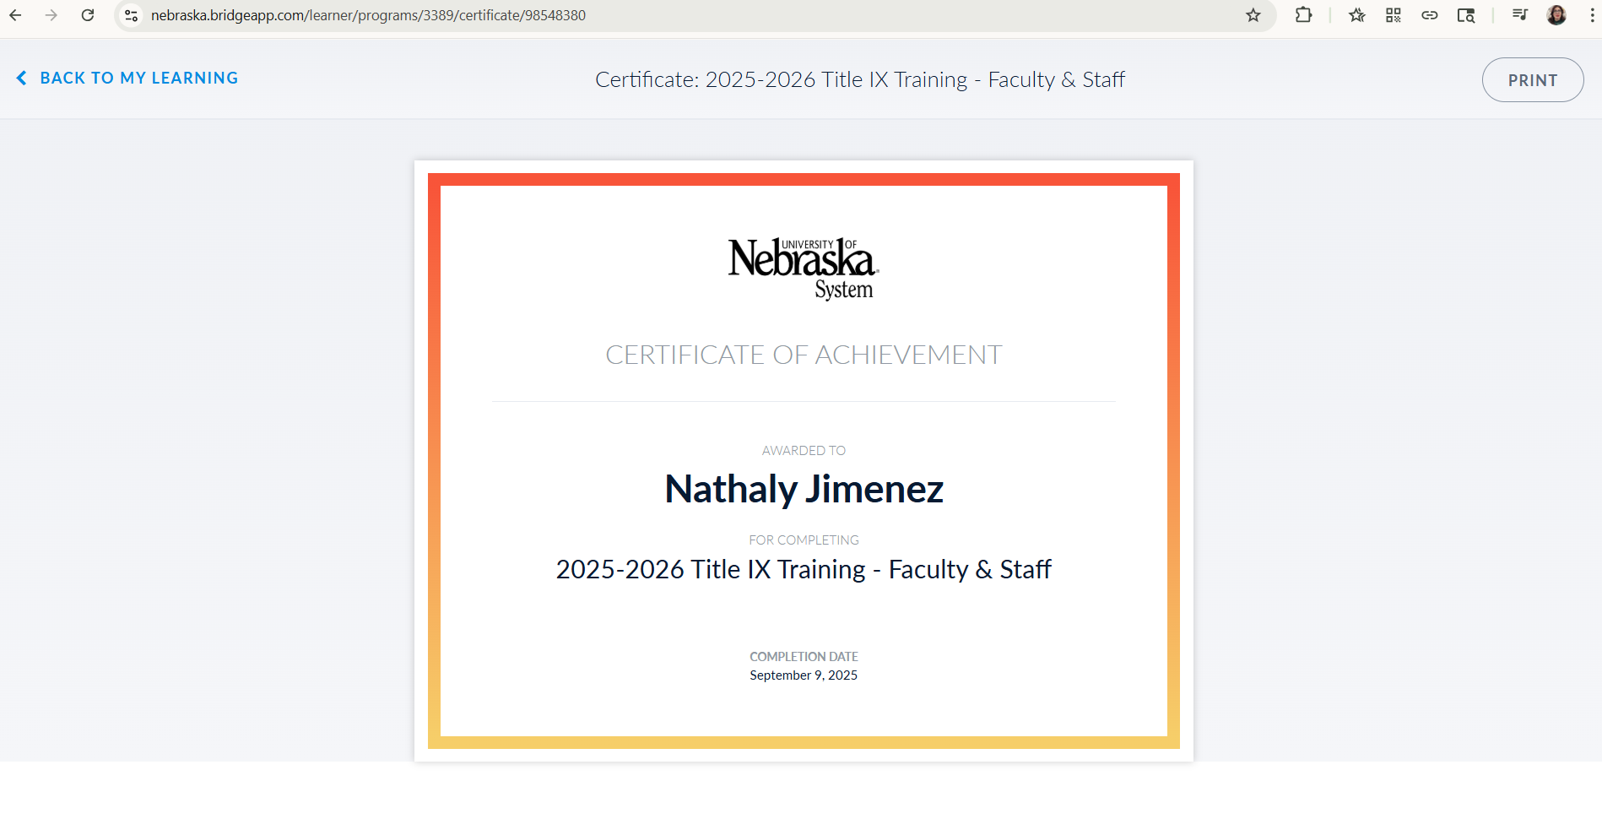
- Click “Print” to print your certificate or to save it as a PDF.
Your Name Here

